The webpages from 2012/07 to 2013 allow users to download the recall information into CSV format.

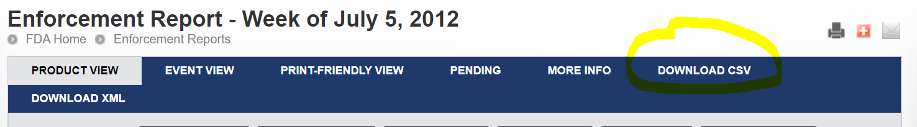

The CSV file organizes the Recall ID, Recalling firm, and the Recalling Firm Location in different columns, so one does not need to scrap the webpage to get them. However, the manufacturer's information is embedded in the *product description* column and needs to be extracted by text processing.

For example, in the above enforcement report, the product description information in recall *D-1083-2015* reads

***"Fexofenadine Hydrochloride Tablets, USP 60 mg, Allergy, Non-Drowsy, Antihistamine, 100 tablets (10 X 10) per UD Cartons, Manufactured by: Mylan Pharmaceuticals Inc., Morgantown, WV 26505, USA, NDC 51079-547-20."***

Similar to the previous cases, some recall enforcement does not include manufacturer information. In those cases, please leave the manufacturer and the manufacturer's location as missing observations.

As you will see, the FDA issued corrections for some weekly reports in 2012 and 2013. We include the correction webpage as the last row of the attached spreadsheet. Please check if there are corrections on the information set you collect. The weekly enforcement reports with corrections have the strings "*Correction Made." In their names.

Please let us if you have any questions. Thanks!